DOKUMENTASI PRATIKUM PERTEMUAN 3


Mata Kuliah : Pemerograman Mobile
Dosen Pengampu :
Jefry Sunupurwa Asri S.Kom, M. Kom
Disusun Oleh :
Gunawan Nastiar (20240801114)

Universitas Esa Unggul
2026
Langkah Pratikum
Bagian A: Input Dasar dengan TextField
Ganti isi lib/main.dart dengan kerangka berikut, lalu tambahkan halaman InputPage.
import 'package:flutter/material.dart';
void main() => runApp(const MyApp());
class MyApp extends StatelessWidget { const MyApp({super.key});
@override Widget build(BuildContext context) { return MaterialApp( title: 'Praktikum 3',
theme: ThemeData(colorSchemeSeed: Colors.blue, useMaterial3: true), home: const InputPage(), );
} }
class InputPage extends StatefulWidget { const InputPage({super.key});
@override
State<InputPage> createState() => _InputPageState(); }
class _InputPageState extends State<InputPage> { final _controller = TextEditingController(); String _salam = '';
@override void dispose() { _controller.dispose(); super.dispose(); }
@override Widget build(BuildContext context) { return Scaffold( appBar: AppBar(title: const Text('Input Dasar')), body: Padding( padding: const EdgeInsets.all(16), child: Column( children: [ TextField( controller: _controller, decoration: const InputDecoration( labelText: 'Nama', border: OutlineInputBorder(), ), ),
const SizedBox(height: 12), ElevatedButton( onPressed: () {
setState(() => _salam = 'Halo, ${_controller.text}!'); }, child: const Text('Sapa'), ),
const SizedBox(height: 12), Text(_salam, style: const TextStyle(fontSize: 20)),
],
),
),
);
}
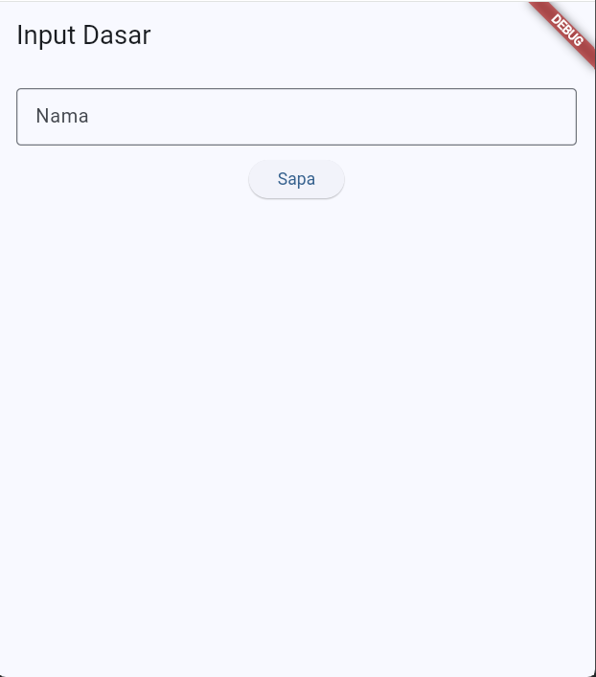
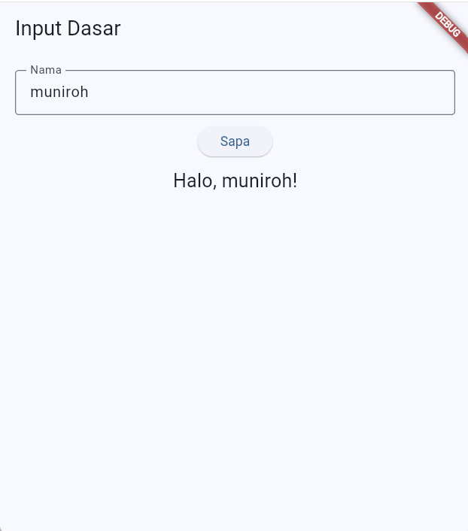
Bagian B: Form dengan Validasi
Buat halaman baru FormPage (di file yang sama), lalu ubah home: menjadi const FormPage().
class FormPage extends StatefulWidget { const FormPage({super.key});
@override
State<FormPage> createState() => _FormPageState(); }
class _FormPageState extends State<FormPage> { final _formKey = GlobalKey<FormState>(); final _nama = TextEditingController(); final _email = TextEditingController(); String? _jurusan; bool _setuju = false;
@override void dispose() { _nama.dispose(); _email.dispose(); super.dispose(); }
void _kirim() { if (_formKey.currentState!.validate()) { final jurusan = _jurusan ?? '-'; ScaffoldMessenger.of(context).showSnackBar(
SnackBar(content: Text('Terdaftar: ${_nama.text} ($jurusan)')),
);
}
}
@override Widget build(BuildContext context) { return Scaffold( appBar: AppBar(title: const Text('Form Pendaftaran')), body: Form( key: _formKey, child: ListView( padding: const EdgeInsets.all(16), children: [ TextFormField( controller: _nama, decoration: const InputDecoration( labelText: 'Nama lengkap', border: OutlineInputBorder(), ), validator: (v) => (v == null || v.trim().isEmpty) ? 'Nama wajib diisi' : null, ),
const SizedBox(height: 12), TextFormField( controller: _email, keyboardType: TextInputType.emailAddress, decoration: const InputDecoration( labelText: 'Email', border: OutlineInputBorder(), ), validator: (v) {
if (v == null || !v.contains('@')) return 'Email tidak valid'; return null; }, ),
const SizedBox(height: 12), DropdownButtonFormField<String>( decoration: const InputDecoration( labelText: 'Jurusan', border: OutlineInputBorder(), ), items: const [ DropdownMenuItem(value: 'TI', child: Text('Teknik Informatika')),
DropdownMenuItem(value: 'SI', child: Text('Sistem Informasi')),
DropdownMenuItem(value: 'TE', child: Text('Teknik Elektro')), ], onChanged: (v) => setState(() => _jurusan = v),
validator: (v) => v == null ? 'Pilih jurusan' : null, ), CheckboxListTile( title: const Text('Saya menyetujui ketentuan'), value: _setuju, controlAffinity: ListTileControlAffinity.leading, onChanged: (v) => setState(() => _setuju = v ?? false), ), ElevatedButton( onPressed: _setuju ? _kirim : null, child: const Text('Daftar'), ),
],
),
),
);
}
}
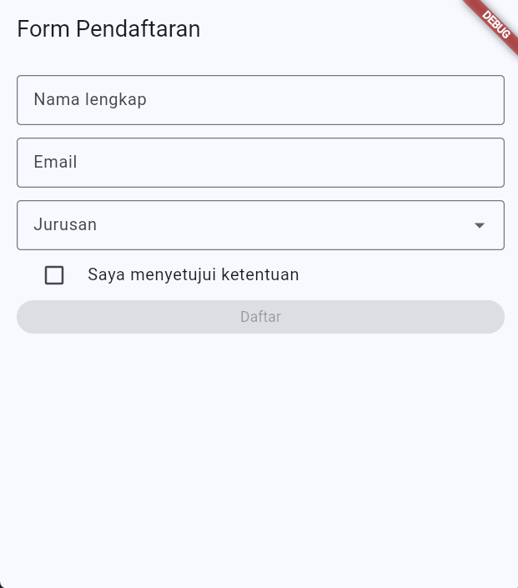
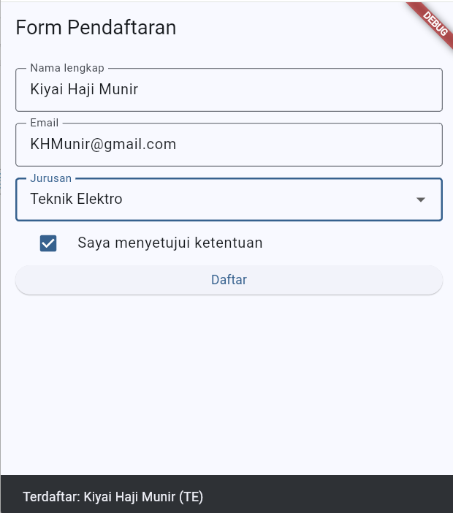
Bagian D: Aplikasi Daftar Tugas dengan Provider
Langkah 1. Pasang paket pada terminal di folder proyek:
flutter pub add provider
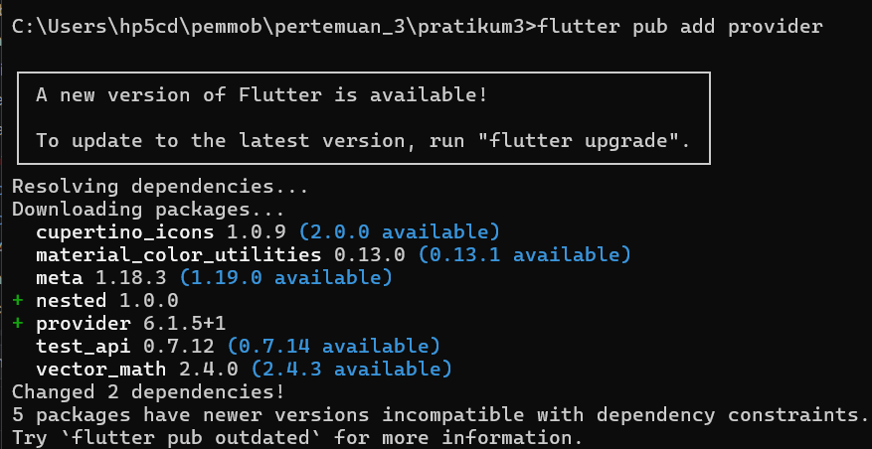
Langkah 2. Ganti seluruh isi lib/main.dart dengan bagian model dan entry point berikut:
import 'package:flutter/material.dart'; import 'package:provider/provider.dart';
class Tugas { String judul; bool selesai; Tugas(this.judul, {this.selesai = false}); }
class TugasModel extends ChangeNotifier { final List<Tugas> _items = [];
List<Tugas> get items => List.unmodifiable(_items); int get jumlahSelesai => _items.where((t) => t.selesai).length;
void tambah(String judul) { _items.add(Tugas(judul)); notifyListeners(); }
void toggle(int index) { _items[index].selesai = !_items[index].selesai; notifyListeners(); }
void hapus(int index) { _items.removeAt(index); notifyListeners(); } }
void main() {
runApp( ChangeNotifierProvider( create: (_) => TugasModel(), child: const MyApp(), ),
); }
class MyApp extends StatelessWidget { const MyApp({super.key});
@override Widget build(BuildContext context) { return MaterialApp( title: 'Daftar Tugas', theme: ThemeData(colorSchemeSeed: Colors.blue, useMaterial3: true), home: const TugasPage(), );
}
}
Langkah 3. Tambahkan halaman daftar. Perhatikan pemakaian context.watch di dalam build dan context.read di dalam callback.
class TugasPage extends StatelessWidget { const TugasPage({super.key});
@override Widget build(BuildContext context) { final model = context.watch<TugasModel>();
return Scaffold( appBar: AppBar( title: Text('Tugas (${model.jumlahSelesai}/${model.items.length})'), ), body: ListView.builder( itemCount: model.items.length, itemBuilder: (context, i) { final t = model.items[i]; return ListTile( leading: Checkbox( value: t.selesai, onChanged: (_) => context.read<TugasModel>().toggle(i), ), title: Text(
t.judul, style: TextStyle(
decoration: t.selesai ? TextDecoration.lineThrough : null, ), ), trailing: IconButton( icon: const Icon(Icons.delete),
onPressed: () => context.read<TugasModel>().hapus(i), ),
);
}, ), floatingActionButton: FloatingActionButton( onPressed: () { Navigator.push( context, MaterialPageRoute(builder: (_) => const TambahPage()),
); }, child: const Icon(Icons.add), ),
);
}
}
Langkah 4. Tambahkan halaman untuk menambah tugas (halaman terpisah, tetapi memakai model yang sama):
class TambahPage extends StatefulWidget { const TambahPage({super.key});
@override
State<TambahPage> createState() => _TambahPageState(); }
class _TambahPageState extends State<TambahPage> { final _controller = TextEditingController();
@override void dispose() { _controller.dispose(); super.dispose(); }
void _simpan() { final judul = _controller.text.trim(); if (judul.isEmpty) return;
context.read<TugasModel>().tambah(judul); Navigator.pop(context);
}
@override Widget build(BuildContext context) { return Scaffold( appBar: AppBar(title: const Text('Tambah Tugas')), body: Padding( padding: const EdgeInsets.all(16), child: Column( children: [ TextField( controller: _controller, autofocus: true, decoration: const InputDecoration( labelText: 'Judul tugas', border: OutlineInputBorder(), ), onSubmitted: (_) => _simpan(), ),
const SizedBox(height: 12), ElevatedButton(onPressed: _simpan, child: const Text('Simpan')),
],
),
),
);
}
}

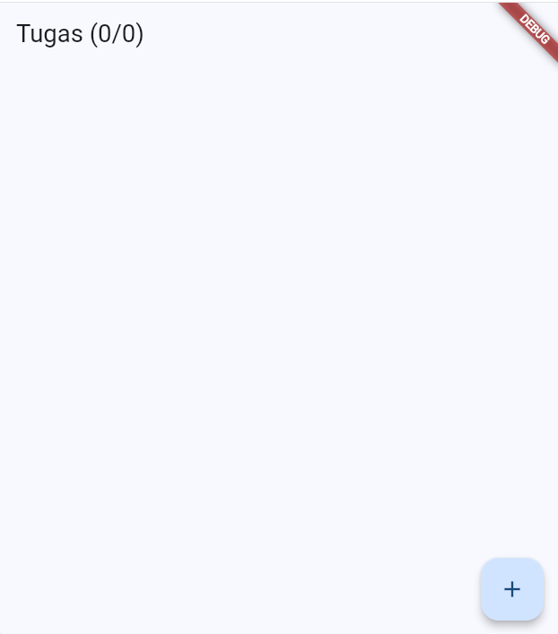
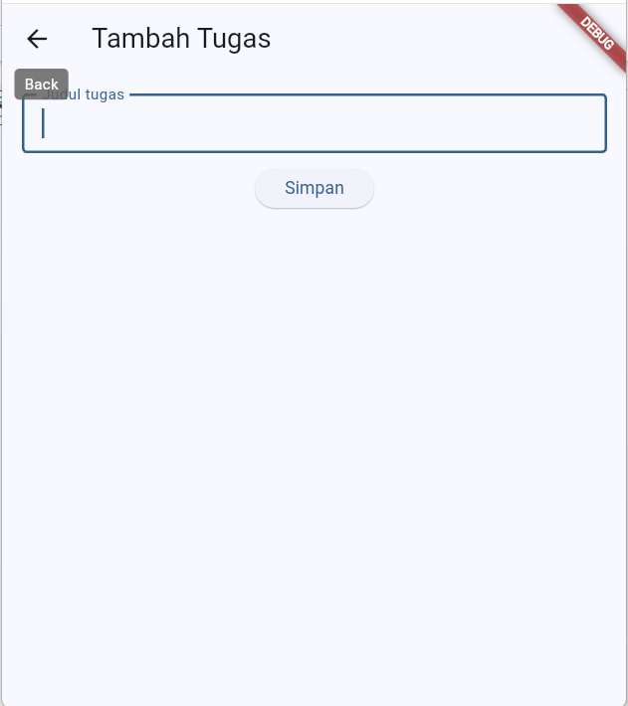
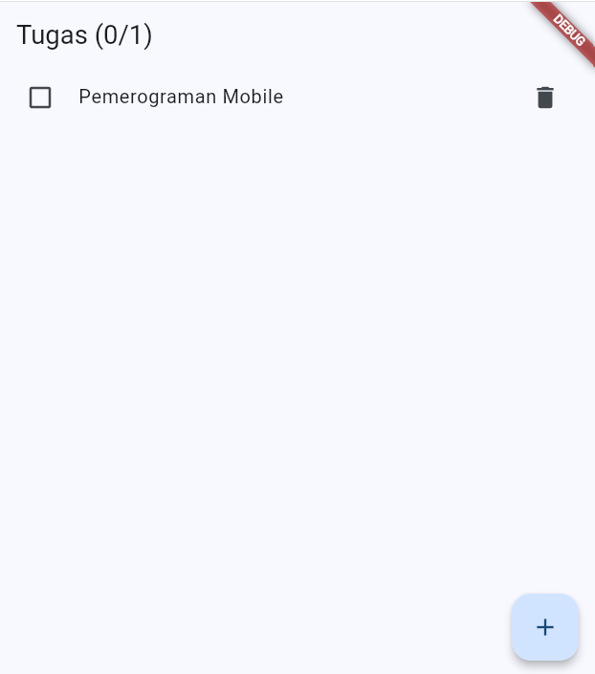
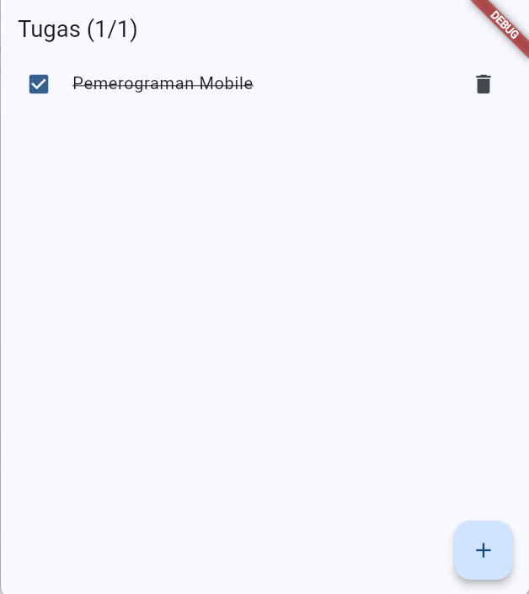
Latihan Mandiri
- Tambahkan validasi pada TambahPage: judul minimal 3 karakter dan tampilkan pesan error (ubah ke TextFormField + Form).
- Tambahkan method hapusSelesai() pada TugasModel dan tombol di AppBar untuk menghapus semua tugas yang sudah selesai.
- Tampilkan SnackBar "Tugas ditambahkan" setelah tugas disimpan.
- Bila daftar kosong, tampilkan teks "Belum ada tugas" di tengah layar.
CODE :
import 'package:flutter/material.dart';
import 'package:provider/provider.dart';
class Tugas {
String judul;
bool selesai;
Tugas(this.judul, {this.selesai = false});
}
class TugasModel extends ChangeNotifier {
final List<Tugas> _items = [];
List<Tugas> get items => List.unmodifiable(_items);
int get jumlahSelesai => _items.where((t) => t.selesai).length;
void tambah(String judul) {
_items.add(Tugas(judul));
notifyListeners();
}
void toggle(int index) {
_items[index].selesai = !_items[index].selesai;
notifyListeners();
}
void hapus(int index) {
_items.removeAt(index);
notifyListeners();
}
// (pengertian) Method untuk menghapus semua tugas yang statusnya sudah selesai.
void hapusSelesai() {
_items.removeWhere((t) => t.selesai);
notifyListeners();
}
}
void main() {
runApp(
ChangeNotifierProvider(
create: (_) => TugasModel(),
child: const MyApp(),
),
);
}
class MyApp extends StatelessWidget {
const MyApp({super.key});
@override
Widget build(BuildContext context) {
return MaterialApp(
title: 'Daftar Tugas',
theme: ThemeData(
colorSchemeSeed: Colors.blue,
useMaterial3: true,
),
home: const TugasPage(),
);
}
}
class TugasPage extends StatelessWidget {
const TugasPage({super.key});
@override
Widget build(BuildContext context) {
final model = context.watch<TugasModel>();
return Scaffold(
appBar: AppBar(
title: Text(
'Tugas (${model.jumlahSelesai}/${model.items.length})',
),
// (pengertian) Tombol untuk menghapus semua tugas yang sudah selesai.
actions: [
IconButton(
icon: const Icon(Icons.delete_sweep),
tooltip: 'Hapus tugas selesai',
onPressed: model.jumlahSelesai == 0
? null
: () {
context.read<TugasModel>().hapusSelesai();
},
),
],
),
// (pengertian) Jika daftar tugas kosong, tampilkan teks di tengah layar.
body: model.items.isEmpty
? const Center(
child: Text(
'Belum ada tugas',
style: TextStyle(fontSize: 18),
),
)
: ListView.builder(
itemCount: model.items.length,
itemBuilder: (context, i) {
final t = model.items[i];
return ListTile(
leading: Checkbox(
value: t.selesai,
onChanged: (_) =>
context.read<TugasModel>().toggle(i),
),
title: Text(
t.judul,
style: TextStyle(
decoration: t.selesai
? TextDecoration.lineThrough
: null,
),
),
trailing: IconButton(
icon: const Icon(Icons.delete),
onPressed: () =>
context.read<TugasModel>().hapus(i),
),
);
},
),
floatingActionButton: FloatingActionButton(
onPressed: () {
Navigator.push(
context,
MaterialPageRoute(
builder: (_) => const TambahPage(),
),
);
},
child: const Icon(Icons.add),
),
);
}
}
class TambahPage extends StatefulWidget {
const TambahPage({super.key});
@override
State<TambahPage> createState() => _TambahPageState();
}
class _TambahPageState extends State<TambahPage> {
final _controller = TextEditingController();
// (pengertian) GlobalKey digunakan untuk mengontrol dan menjalankan validasi Form.
final _formKey = GlobalKey<FormState>();
@override
void dispose() {
_controller.dispose();
super.dispose();
}
void _simpan() {
// (pengertian) validate() menjalankan validator pada TextFormField.
if (!_formKey.currentState!.validate()) {
return;
}
final judul = _controller.text.trim();
context.read<TugasModel>().tambah(judul);
// (pengertian) Menampilkan SnackBar sebagai notifikasi bahwa tugas berhasil ditambahkan.
ScaffoldMessenger.of(context).showSnackBar(
const SnackBar(
content: Text('Tugas ditambahkan'),
),
);
Navigator.pop(context);
}
@override
Widget build(BuildContext context) {
return Scaffold(
appBar: AppBar(
title: const Text('Tambah Tugas'),
),
body: Padding(
padding: const EdgeInsets.all(16),
child: Form(
// (pengertian) Form digunakan untuk mengelompokkan input yang membutuhkan validasi.
key: _formKey,
child: Column(
children: [
TextFormField(
controller: _controller,
autofocus: true,
decoration: const InputDecoration(
labelText: 'Judul tugas',
border: OutlineInputBorder(),
),
// (pengertian) Validator memastikan judul tidak kosong dan minimal memiliki 3 karakter.
validator: (value) {
if (value == null || value.trim().isEmpty) {
return 'Judul tugas wajib diisi';
}
if (value.trim().length < 3) {
return 'Judul tugas minimal 3 karakter';
}
return null;
},
// (pengertian) Ketika user menekan Enter, fungsi _simpan() akan dijalankan.
onFieldSubmitted: (_) => _simpan(),
),
const SizedBox(height: 12),
ElevatedButton(
onPressed: _simpan,
child: const Text('Simpan'),
),
],
),
),
),
);
}
}

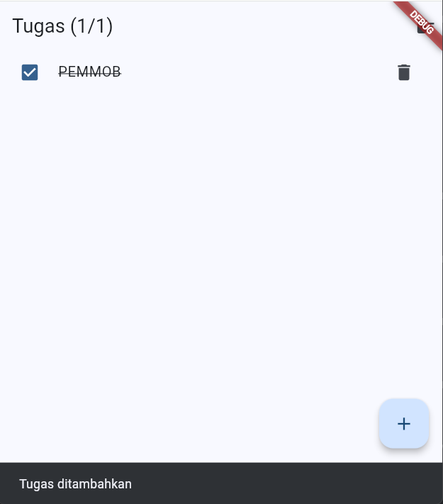
Tugas
Buat aplikasi Daftar Belanja dengan ketentuan:
- Halaman Form Tambah: nama barang (wajib), jumlah (wajib, angka lebih dari 0), dan kategori (dropdown), dengan validasi pada setiap isian.
- Halaman Daftar: menampilkan semua barang, dapat dicentang sebagai "sudah dibeli" dan dihapus.
- State disimpan pada satu ChangeNotifier dan dibagikan dengan Provider; AppBar menampilkan jumlah barang yang belum dibeli.
- Kumpulkan: tangkapan layar kedua halaman (termasuk tampilan pesan error validasi) dan berkas main.dart (atau tautan repositori).
- import 'package:flutter/material.dart';
import 'package:provider/provider.dart';
// ============================================================
// MODEL DATA BARANG
// ============================================================
class Barang {
String nama;
int jumlah;
String kategori;
bool sudahDibeli;
Barang({
required this.nama,
required this.jumlah,
required this.kategori,
this.sudahDibeli = false,
});
}
// ============================================================
// CHANGE NOTIFIER
// ============================================================
class BelanjaModel extends ChangeNotifier {
final List<Barang> _items = [];
List<Barang> get items => List.unmodifiable(_items);
// Jumlah barang yang belum dibeli
int get jumlahBelumDibeli =>
_items.where((barang) => !barang.sudahDibeli).length;
// Menambahkan barang
void tambahBarang(
String nama,
int jumlah,
String kategori,
) {
_items.add(
Barang(
nama: nama,
jumlah: jumlah,
kategori: kategori,
),
);
notifyListeners();
}
// Mengubah status sudah dibeli / belum
void toggleDibeli(int index) {
_items[index].sudahDibeli = !_items[index].sudahDibeli;
notifyListeners();
}
// Menghapus barang
void hapusBarang(int index) {
_items.removeAt(index);
notifyListeners();
}
}
// ============================================================
// MAIN
// ============================================================
void main() {
runApp(
ChangeNotifierProvider(
create: (_) => BelanjaModel(),
child: const MyApp(),
),
);
}
// ============================================================
// MY APP
// ============================================================
class MyApp extends StatelessWidget {
const MyApp({super.key});
@override
Widget build(BuildContext context) {
return MaterialApp(
debugShowCheckedModeBanner: false,
title: 'Daftar Belanja',
theme: ThemeData(
colorSchemeSeed: Colors.blue,
useMaterial3: true,
),
home: const DaftarPage(),
);
}
}
// ============================================================
// HALAMAN DAFTAR
// ============================================================
class DaftarPage extends StatelessWidget {
const DaftarPage({super.key});
@override
Widget build(BuildContext context) {
final model = context.watch<BelanjaModel>();
return Scaffold(
appBar: AppBar(
title: Text(
'Daftar Belanja (${model.jumlahBelumDibeli} belum dibeli)',
),
),
body: model.items.isEmpty
? const Center(
child: Text(
'Belum ada barang',
style: TextStyle(fontSize: 18),
),
)
: ListView.builder(
itemCount: model.items.length,
itemBuilder: (context, index) {
final barang = model.items[index];
return ListTile(
leading: Checkbox(
value: barang.sudahDibeli,
onChanged: (_) {
context
.read<BelanjaModel>()
.toggleDibeli(index);
},
),
title: Text(
barang.nama,
style: TextStyle(
fontSize: 17,
decoration: barang.sudahDibeli
? TextDecoration.lineThrough
: null,
),
),
subtitle: Text(
'${barang.jumlah} • ${barang.kategori}',
),
trailing: IconButton(
icon: const Icon(Icons.delete),
onPressed: () {
context
.read<BelanjaModel>()
.hapusBarang(index);
},
),
);
},
),
floatingActionButton: FloatingActionButton(
onPressed: () {
Navigator.push(
context,
MaterialPageRoute(
builder: (_) => const TambahBarangPage(),
),
);
},
child: const Icon(Icons.add),
),
);
}
}
// ============================================================
// HALAMAN FORM TAMBAH
// ============================================================
class TambahBarangPage extends StatefulWidget {
const TambahBarangPage({super.key});
@override
State<TambahBarangPage> createState() =>
_TambahBarangPageState();
}
class _TambahBarangPageState extends State<TambahBarangPage> {
final _formKey = GlobalKey<FormState>();
final _namaController = TextEditingController();
final _jumlahController = TextEditingController();
String? _kategori;
final List<String> _kategoriList = [
'Makanan',
'Minuman',
'Kebutuhan Rumah',
'Elektronik',
'Lainnya',
];
@override
void dispose() {
_namaController.dispose();
_jumlahController.dispose();
super.dispose();
}
// Menyimpan barang
void _simpan() {
// Menjalankan semua validasi Form
if (!_formKey.currentState!.validate()) {
return;
}
final nama = _namaController.text.trim();
final jumlah = int.parse(_jumlahController.text.trim());
context.read<BelanjaModel>().tambahBarang(
nama,
jumlah,
_kategori!,
);
Navigator.pop(context);
}
@override
Widget build(BuildContext context) {
return Scaffold(
appBar: AppBar(
title: const Text('Tambah Barang'),
),
body: Padding(
padding: const EdgeInsets.all(16),
child: Form(
key: _formKey,
child: Column(
children: [
// ==================================================
// NAMA BARANG
// ==================================================
TextFormField(
controller: _namaController,
decoration: const InputDecoration(
labelText: 'Nama barang',
hintText: 'Contoh: Beras',
border: OutlineInputBorder(),
),
validator: (value) {
if (value == null ||
value.trim().isEmpty) {
return 'Nama barang wajib diisi';
}
return null;
},
),
const SizedBox(height: 16),
// ==================================================
// JUMLAH
// ==================================================
TextFormField(
controller: _jumlahController,
keyboardType: TextInputType.number,
decoration: const InputDecoration(
labelText: 'Jumlah',
hintText: 'Contoh: 2',
border: OutlineInputBorder(),
),
validator: (value) {
if (value == null ||
value.trim().isEmpty) {
return 'Jumlah wajib diisi';
}
final jumlah = int.tryParse(
value.trim(),
);
if (jumlah == null) {
return 'Jumlah harus berupa angka';
}
if (jumlah <= 0) {
return 'Jumlah harus lebih dari 0';
}
return null;
},
),
const SizedBox(height: 16),
// ==================================================
// KATEGORI
// ==================================================
DropdownButtonFormField<String>(
value: _kategori,
decoration: const InputDecoration(
labelText: 'Kategori',
border: OutlineInputBorder(),
),
items: _kategoriList.map((kategori) {
return DropdownMenuItem(
value: kategori,
child: Text(kategori),
);
}).toList(),
onChanged: (value) {
setState(() {
_kategori = value;
});
},
validator: (value) {
if (value == null || value.isEmpty) {
return 'Kategori wajib dipilih';
}
return null;
},
),
const SizedBox(height: 24),
// ==================================================
// BUTTON SIMPAN
// ==================================================
SizedBox(
width: double.infinity,
child: ElevatedButton(
onPressed: _simpan,
child: const Text('Simpan'),
),
),
],
),
),
),
);
}
}
